What is Vector Embedding and Vector Store?
A vector is a list of numbers that represents data in a mathematical space. Think of it like GPS coordinates but with many dimensions instead of just latitude and longitude.
Text-to-vector conversion transforms written text into numerical representations that computers can process. This process takes words or phrases and maps them to multi-dimensional space where each dimension represents a different feature or meaning. Think of it like converting a recipe into a list of ingredient quantities - the recipe "two cups flour, one cup sugar" becomes [2, 1] in vector form. Modern embedding models like those from OpenAI use neural networks to create these vectors, ensuring that similar concepts (like "happy" and "joyful") end up close to each other in this mathematical space, while different concepts ("happy" and "table") end up far apart. These vectors enable computers to measure text similarity, perform searches, and understand relationships between words using mathematical operations.
A vector store is a data structure that stores vectors (typically embeddings) and their corresponding metadata. It is used to efficiently retrieve similar vectors based on a query vector. Vector stores are commonly used in RAG (Retrieval-Augmented Generation) workflows, where the goal is to find the most relevant documents or pieces of information to support the generation of a response.
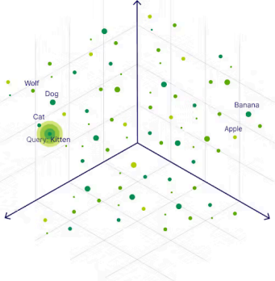
(Source)
This diagram is a 3D representation of how vector search works using embeddings in a vector space. Each data point (e.g., "Wolf," "Dog," "Cat," "Banana," "Apple") represents a high-dimensional vector derived from the semantic meaning of the text. These embeddings are plotted closer together if their meanings are similar.
For example, the query "Kitten" generates a vector that is plotted in the same space. In this visualization, "Kitten" is closer to "Cat" and "Dog," as they share semantic similarity, while it is farther away from unrelated concepts like "Banana" or "Apple."
The vector search process involves:
1. Encoding: Transforming text, images, or other data into embeddings (numerical vectors). 2. Similarity Search: Measuring distances (e.g., cosine similarity or Euclidean distance) between the query vector and other vectors in the space.
3. Results: Returning the closest data points, which are the most semantically relevant to the query.
This approach underpins retrieval tasks in modern AI systems, such as semantic search, recommendation engines, and Retrieval-Augmented Generation (RAG).

